DBMS Lab: SQL Joins and Transactions
2520090137 - Jayavarapu Sri Charan
Use the following tables:
- Employees
- Departments
- Projects
- Customers
- Orders
- Products
- Order_Details
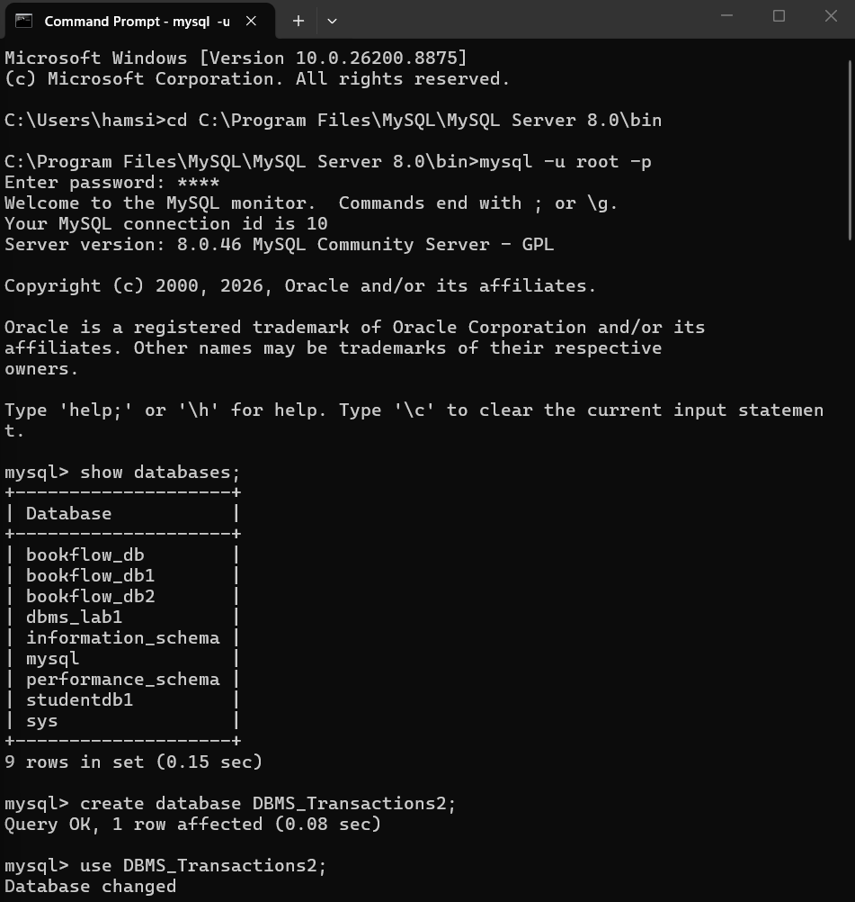
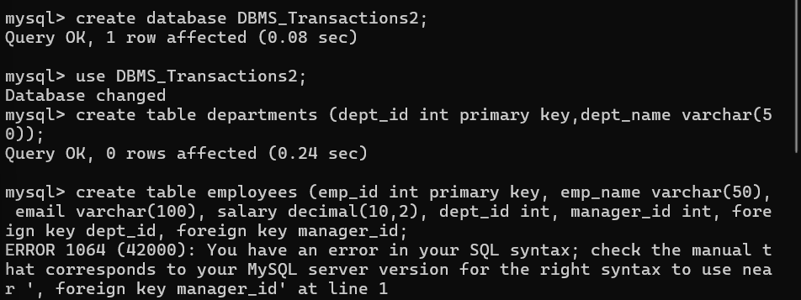
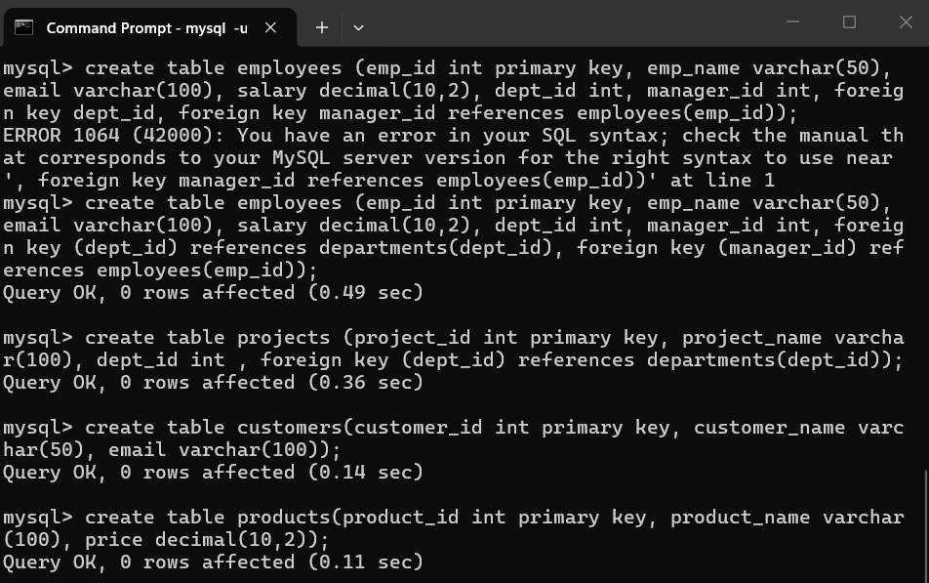
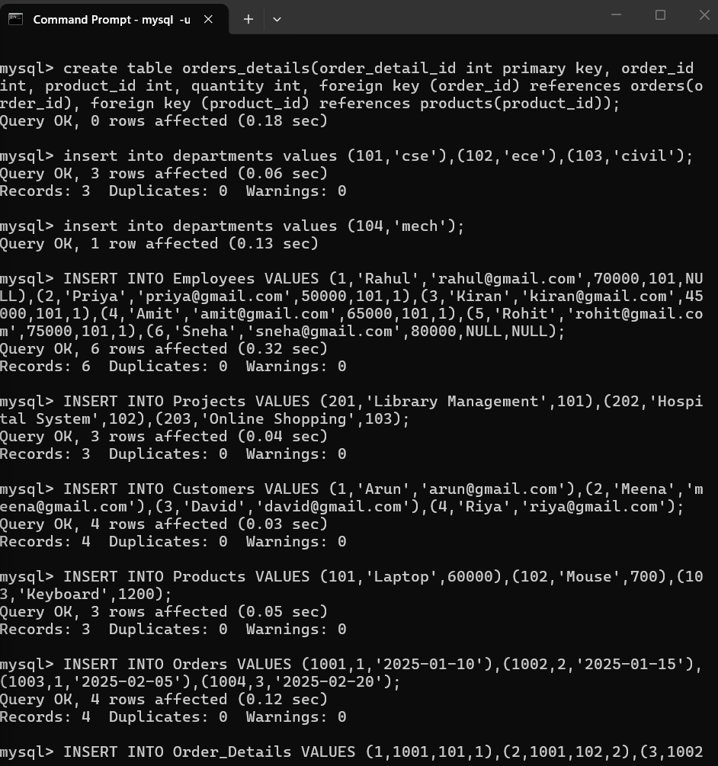
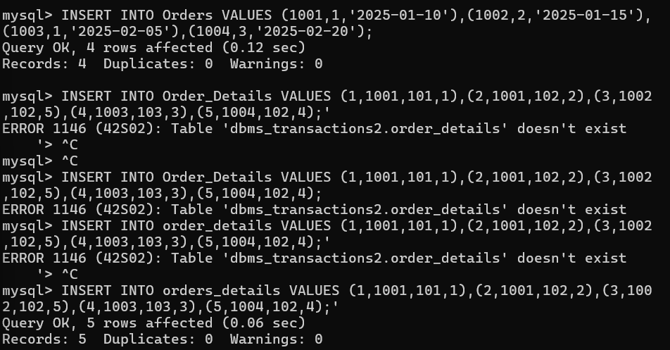
DML Operations:
- Insert a new employee into the Employees table.
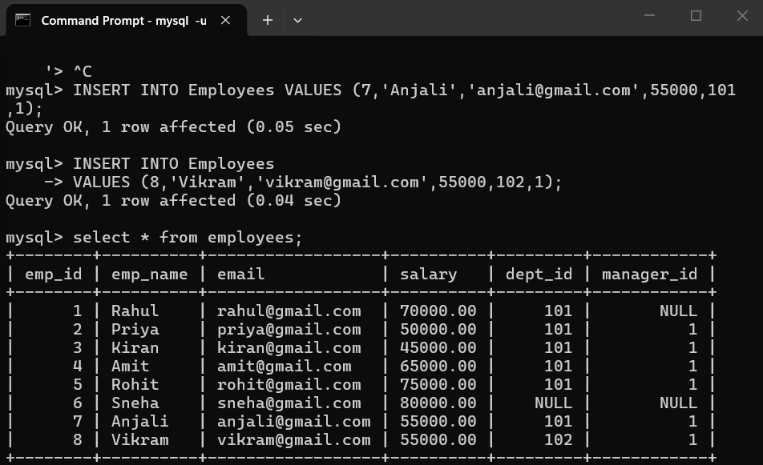
- Update the salary of employees working in the CSE department by 10%.
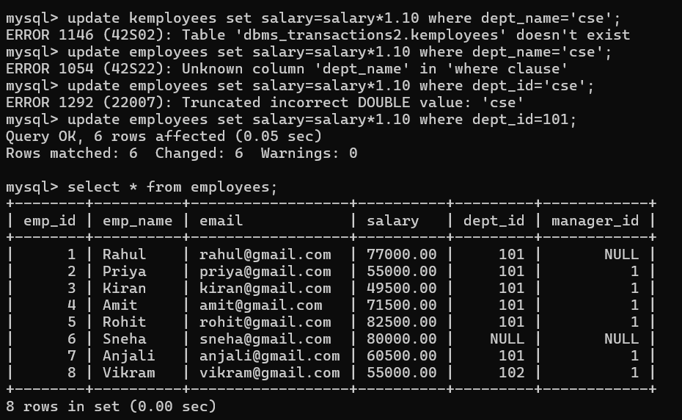
- Delete employees whose salary is below ₹30,000.
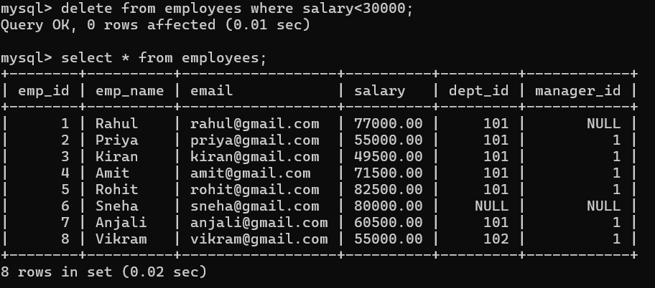
- Display all employee details.
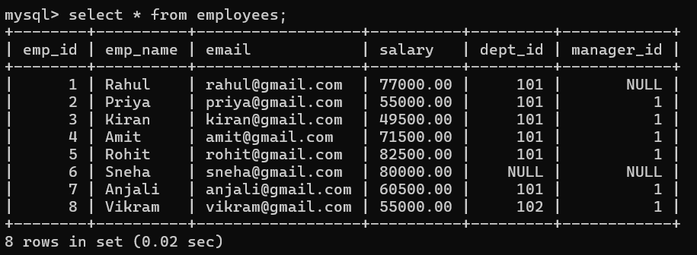
JOIN Queries:
- Display employee names along with department names.
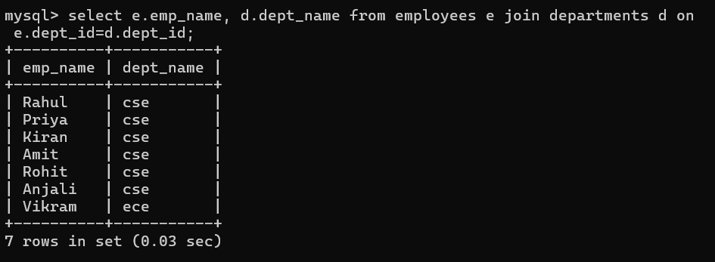
- Display employees who do not belong to any department.
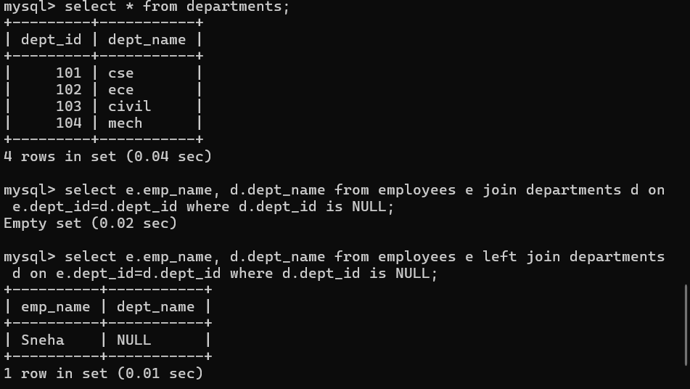
- Display all departments even if they have no employees.
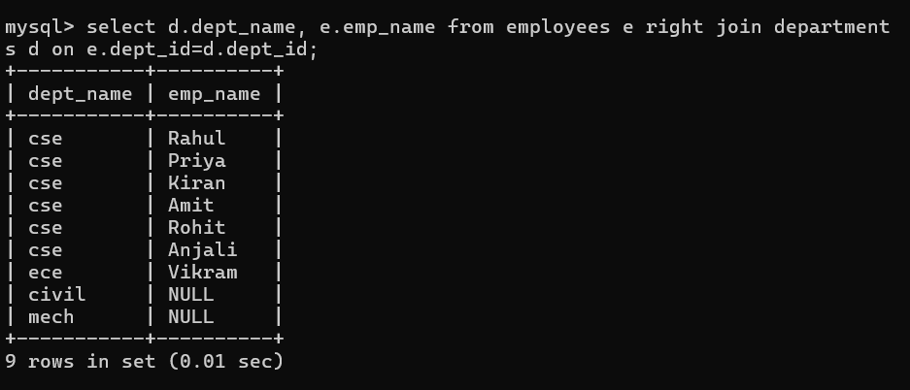
- Display employee and manager names using SELF JOIN.
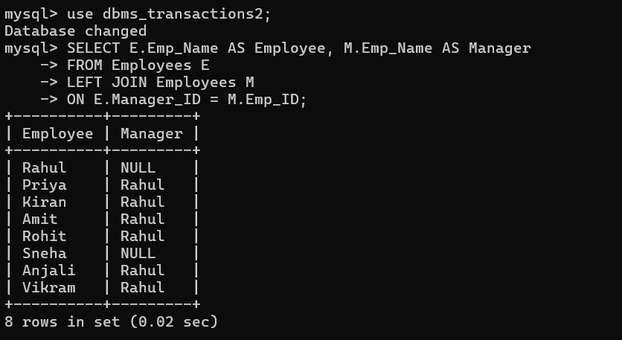
Aggregate Functions:
- Find the total number of employees.
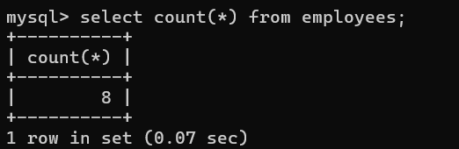
- Find department-wise average salary.
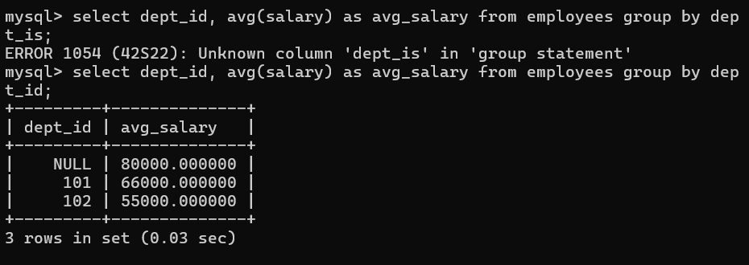
- Display departments where average salary exceeds ₹60,000.
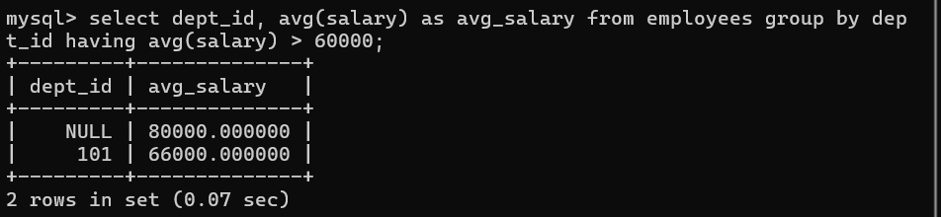
- Display the highest and lowest salary.
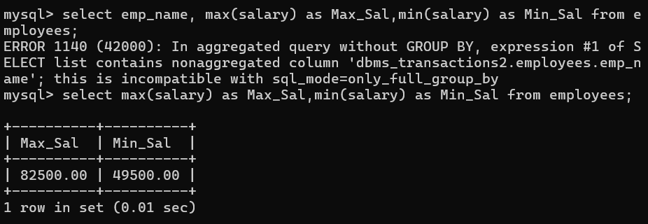
Subqueries:
- Display employees earning more than the average salary.
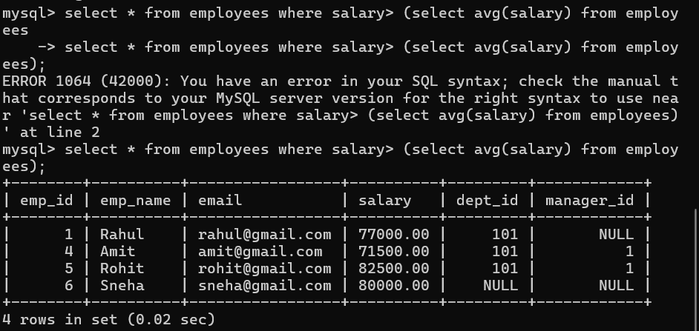
- Find employees working in the same department as Rahul.
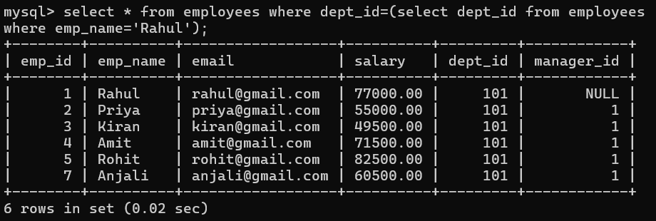
- Display the employee receiving the highest salary.
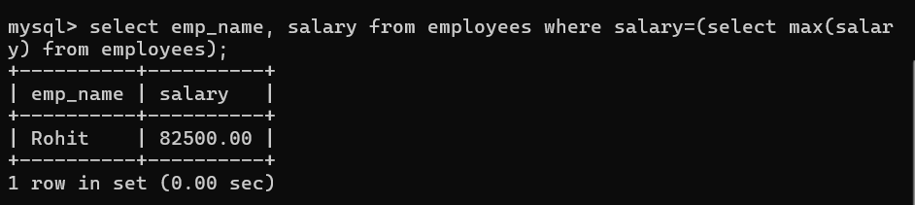
- Display departments having more than five employees.
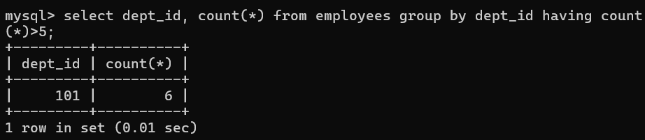
- Find the second-highest salary using a window function.
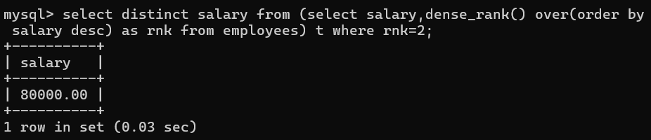
- Display employees earning above their department's average salary.
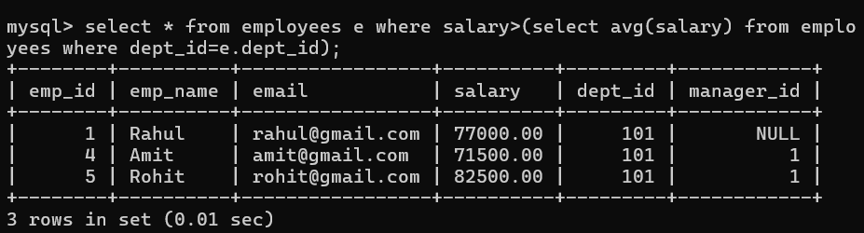
- Find customers who have never placed an order.
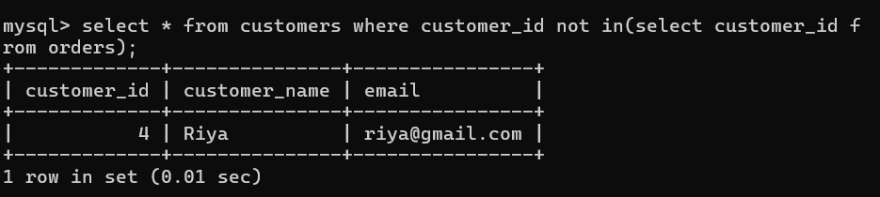
- Display the top-selling product.
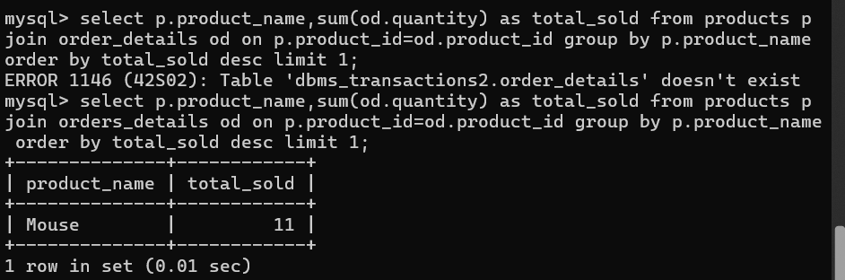
- Find departments with the maximum number of employees.
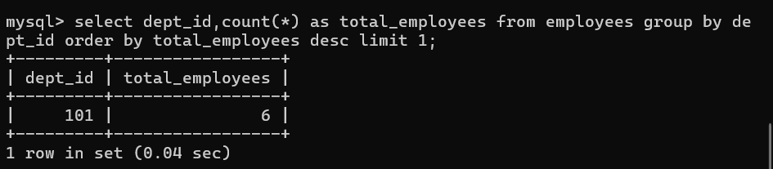
- Display monthly sales using window functions.
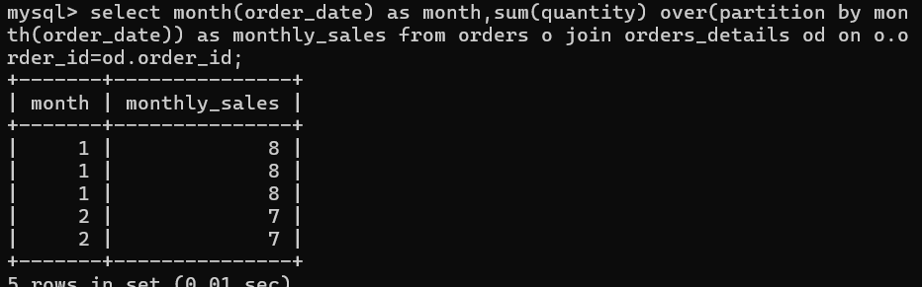
- Rank customers based on total purchase amount.
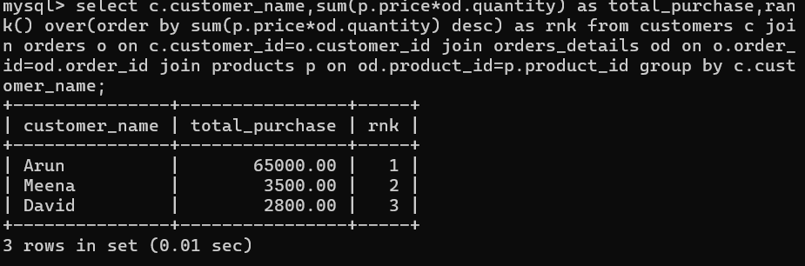
- Display employees whose salary is greater than their manager's salary.
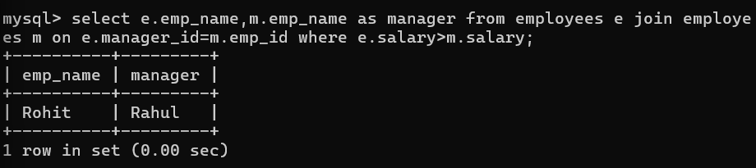
- Find duplicate email addresses using GROUP BY and HAVING.

